**HOW TO READ YOUR METER**

Reading your natural gas meter is one way to tell how much natural gas you're using each month. To accurately read your natural gas meter, follow the steps below:

1. Read the dials left to right.
2. If the hand is between two numbers, **always select the lower number**.
3. When the hand is between "9" and "0," then "9" is considered the lower number.
4. When the hand looks as though it is DIRECTLY on the number, look at the dial to the right. If the dial on the right has passed "0," use the number that the hand is on. If the dial on the right has not passed "0," use the number less than what the hand is on.

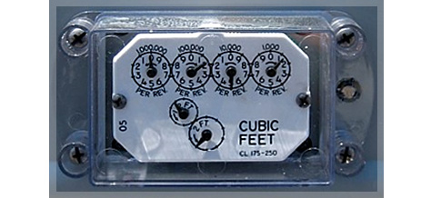

*Remember to record the lower number if the dial is between two numbers. For this example, read from left to right.*

* The first dial is turning counter-clockwise. It points between the "0" and the "1."  
  **Read this dial as 0.**
* The second dial is between "1" and "2." It might even look as though it is on the "2," but you can see that the dial is to the left. Read the lower number.  
  **Read this dial as 1.**
* The third dial is turning counter-clockwise and is just after the "5."  
  **Read this dial as 5.**
* The fourth dial is turning clockwise and is between the "1" and the "2."  
  **Read this dial as "1."**

**The correct reading for this meter is 0151.**